Height-of-Burst Curves Revisited

John M. Dewey and Alex A. van Netten
Dewey McMillin & Associates Ltd
1741 Feltham Rd, Victoria, B.C. V8N 2A4
Canada

Abstract
When an explosion occurs at some height above the ground surface, it produces a spherical blast wave that interacts with the ground. The physical properties of the blast wave vary with distance from ground zero (GZ), and for a given charge size, depend on the height-of-burst (HOB). The loci of specific blast properties, such as isobars of peak hydrostatic overpressure, can be plotted for a specified charge size, in the HOB - ground range plane. These are known as height-of-burst curves.
The peak pressure immediately behind the reflected shock of a regular reflection (RR) can be calculated using the von Neumann two-shock theory. For intermediate and low shock strengths, this theory predicts a significant increase of pressure just before transition to Mach reflection (MR), and this increase has a large effect on the HOB curves, giving them pronounced “knees”. This means that there are high overpressures at unexpectedly large distances from GZ, and the peak overpressures in some regions may increase rather than decrease with distance. In order to predict the hazards from a HOB explosion it is important to have trustworthy HOB curves.
The earliest HOB curves, produced using two-shock theory, showed pronounced knees for peak hydrostatic overpressure, but these were not confirmed by experimental measurements on HOB tests with nuclear and chemical explosives. The HOB curves were therefore redrawn without the knees, and questions were raised about the validity of the pressure increase predicted by theory in the region of transition from RR to MR. Pressure increases were observed in shock tube experiments involving the reflection of plane shocks from plane wedges, but not in experiments in which the shocks reflected from curved surfaces when there was a dynamic transition from RR to MR. An extensive set of experiments by Reichenbach and Kuhl^{[1]}, using 0.5 g charges detonated above plane rigid surfaces, also failed to show any pressure increase at transition.
More recently, van Netten and Dewey^{[2]} made numerical simulations of plane shock reflections from curved surfaces, and these showed a pressure increase at transition, the magnitude of which was dependent on the resolution of the calculational grid. The pressure increases were confirmed in shock tube experiments using very small and sensitive pressure transducers mounted in a reflecting surface with a large radius of curvature. As a result of these findings, the data from HOB field experiments have been re-examined and a number of these show a pressure increase at transition. The AirBlast expert system has been used to interpolate between the experimental results so that a revised set of HOB curves can be drawn. These curves do have knees, but not as pronounced as those predicted by two-shock theory.
Reasons why the pressure increase at transition may not have been detected in some of the nuclear and chemical HOB experiments, are suggested. It is also be hypothesized that the extent of the knees in HOB curves is dependant on the size of the explosion and the relative size and sensitivity of the detection system, be it pressure transducer or loaded structure. In other words, applicable HOB curves are charge-yield dependent.

Theory
When a centred explosion occurs at a height H above the ground (fig. 1), the incident spherical shock is initially reflected as a RR. As the blast wave expands, the angle of incidence between the incident shock and the ground increases, and there is a transition to MR. This problem was initially studied by von Neumann, for which purpose he developed his two- and three-shock theories (von Neumann^{[3,4]}). Using these theories, von Neumann was able to calculate the way in which the pressure behind the reflected and Mach stem shocks would vary with angle of incidence for a specific incident shock Mach number. The analysis predicted a large increase of pressure in the region of transition from RR to MR, such that the pressure for an angle of incidence of approximately 45⁰ might be even larger than that behind a normally reflected shock. Experiments in which uniform plane shocks were reflected from plane wedges with a range of different angles of inclination, confirmed that there was an increase of pressure at transition, although the measured increase was never as large as that predicted by the two-shock and three-shock theories.
Figure 1. An explosion at a height H above the ground produces an incident shock, i, which initially reflects as a regular reflection (RR), and later as a Mach reflection (MR). r and m are the reflected and Mach stem shocks, respectively.
H
i
i
r
r
m
RR
MR
The two-shock and three-shock theories were used to calculate height-of-burst curves for nuclear explosions detonated above the ground (fig. 2). Height-of-burst curves show the isobars of maximum overpressure along the ground in the height-of-burst - ground-range plane, where the ground range is measured from ground zero (GZ), the point on the ground immediately beneath the explosion. The curves are drawn for an explosion of unit TNT-equivalent energy yield, which is 1 kt for a nuclear explosion, assuming that approximately half the energy is released in the blast wave and the remainder as thermal and nuclear radiation. The height-of-burst curves calculated in this way show a considerable extension of the isobars in the region of transition from regular to Mach reflection, indicating that there may be an extended region in which the overpressure will increase with increasing distance from GZ, e.g. the 100 psi to 10 psi isobars in fig. 2. These extended regions of the isobars have been called the “knees”.

Observations
With the advent of nuclear testing, pressure measurements were made along the ground from explosions at different heights of burst, but the theoretically predicted increase of pressure in the region of transition from RR to MR was not observed. Consequently, the official height-of-
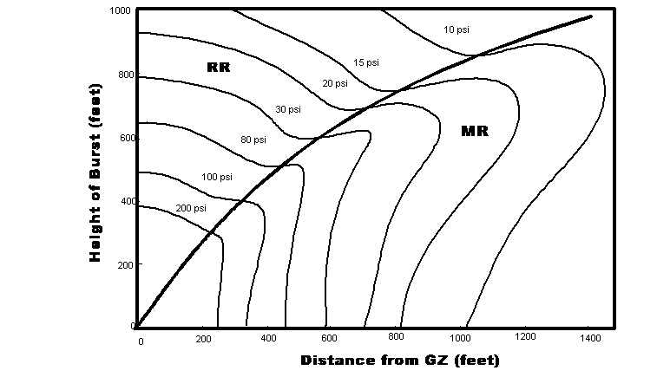
Figure 2. Original 1 kt nuclear height-of-burst curves showing extended “knees” due to the predicted pressure increase at transition from regular to Mach reflection (Brode^{[5]}).

burst curves were modified and did not show the extended higher pressures in the transition region. Shock tube experiments, in which plane steady shocks were reflected from plane rigid surfaces, did show an increase of pressure at transition. However, in the height-of-burst situation, there is a gradual increase in the angle of incidence so that the shock reflection changes continuously from RR to MR. This can be simulated in a shock tube by allowing a plane shock to interact with a circular cylinder. Pressure gauges can be flush mounted in the cylinder to measure the pressure-time history at any position. Experiments such as these were carried out in several laboratories, but no increase of pressure in the transition region was detected.
The absence of knees in height-of-burst curves was further confirmed by the extensive and elegant series of experiments by Reichenbach and Kuhl^{[1]}, carried out at Ernst Mach Institut using 0.5 g Nitropenta charges detonated above a rigid reflecting surface. Height-of-burst curves using the results from these experiments are shown in fig. 3.

Further analysis, experiments and observations
The absence of knees in the height-of-burst curves based on results from nuclear tests; the Nitropenta experiments of Reichenbach and Kuhl, and the shock tube experiments using circular cylinders, still left a nagging doubt. Why was the pressure increase predicted by two-shock theory, and demonstrated in shock tube experiments with plane wedges, not observed in situations with a continuously varying angle of incidence? One suggestion was that the increase of pressure in the varying-angle-of-incidence configuration was a short-lived phenomenon, which was not detected by the relatively large gauges used in the cylinder and Nitropenta experiments. To investigate this possibility, a pressure transducer was developed with a rapid response time and a small sensitive cross-section of approximately 1mm.
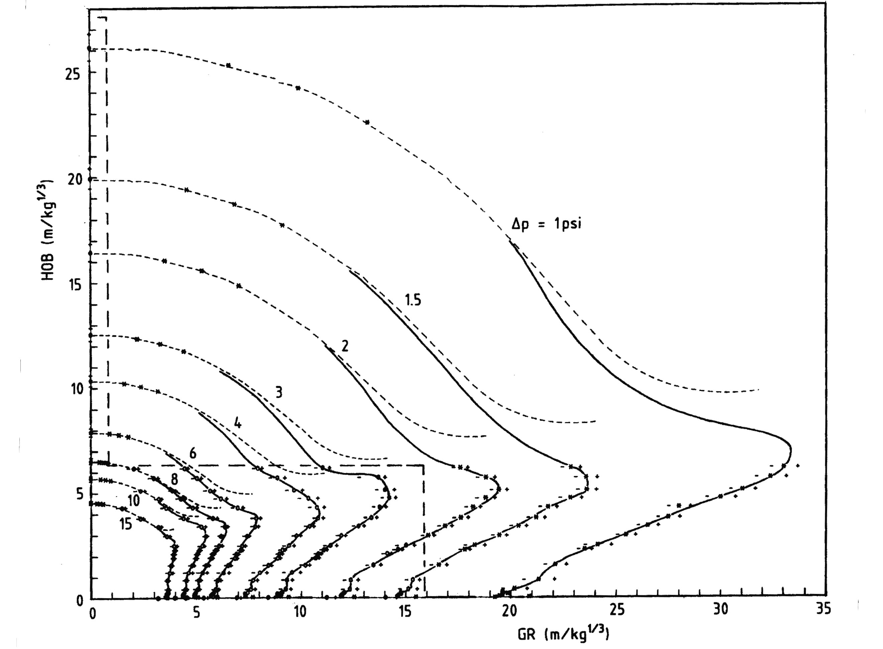
Figure 3. Height-of-burst curves from Reichenbach and Kuhl^{[1]}, derived from experiments using 0.5 g charges detonated above a smooth rigid surface.

Initially, the gauge was used to record the peak pressure along the surface of a plane wedge exposed at various angles of incidence, to a plane incident shock with a Mach number of 1.2. The interactions were also simulated using the Adaptable Weighted Average Flux (AWAF) code, which had been developed to study this type of problem. The results from the experiments and the simulations confirmed a significant pressure increase, which reached a peak value slightly after the theoretical point of transition from regular to Mach reflection.
The small gauge was then used to study the peak pressure along the surface of a curved wedge with a radius of curvature of 1.42 m, and exposed to a Mach 1.2 plane incident shock. Only a section of the cylinder could be used in the 25 cm diameter shock tube. A series of experiments was carried out with the gauge in various positions throughout the transition region, and parallel simulations were made with the AWAF code. The experiments and the simulation showed a significant increase of pressure in the transition region. This may have been the first time in which an increase of pressure at transition has been observed on a curved wedge. The magnitude of the peak pressure calculated by the numerical code depended on the spatial resolution, which confirmed the need to use very small, high-frequency-response gauges for this type of measurement. (van Netten and Dewey^{[2]})

Height-of-Burst Curves Revisited
Why do the Reichenbach and Kuhl results not show any pressure increase at transition? This may have been because they used very small 0.5 g charges, and relatively large, ≅ 0.5 cm diameter gauges. However, using appropriate scaling factors, the Reichenbach and Kuhl curves compared well with a limited number of results from nuclear tests, and with results from an extensive series of experiments carried out at Defence Research Establishment Suffield (DRES) using 450 kg charges at a wide range of heights of burst (Anderson^{[6]}). In the report of these experiments, Anderson states that the pressures in the transition region appear to be significantly higher than those predicted by the official height-of-burst curves at that time, but this higher pressure is not apparent from the published gauge measurements.
At this point, we should consider how experimental height-of-burst curves are drawn. On a single height-of-burst experiment, the overpressure is measured at a series of distances from ground zero, using gauges flush mounted in plates at ground level, or in ‘lollipop’ mounts at some distance above the ground. The peak pressure is then read from the recorded pressure-time record. The accuracy of this measurement depends on several things, such as: the accuracy of the way in which the gauge, pre-amplifier and amplifier have been calibrated so as to relate pressure to the recorded voltage; the absence of sensitivity of the gauge to temperature changes, acceleration and other sources of noise; the absence of reflected shocks and pressure pulses from structures close to the gauge, and the frequency response of the gauge. In some cases, in order to determine the peak pressure, it may be necessary to subjectively extrapolate the pressure-time signal back to the time of arrival of the shock at the gauge.
For these, and other reasons, the individual measurements of peak pressure, when plotted as a function of distance from ground zero, do not form a smooth curve, and such a curve is usually drawn through the points by eye, by a fitting technique, or produced by a numerical simulation. The distances at which specific pressure values, e.g. 15 psi, 10 psi, and 5 psi, occurred are then interpolated from the curve. Any unexpectedly higher pressure, recorded by only one or two gauges, tends to be ignored when the smoothing curve is drawn. The interpolated pressures from this curve are then used to create the HOB curves, thus ignoring any increase of pressure in the narrow transition region.
This is illustrated in fig. 4a, which shows the hydrostatic pressure measurements made along or close to the ground, in two height-of-burst experiment using a 1,000 lb charges (Reisler, Dixon and Keefer^{[7]}). In these experiments, several additional gauges were deployed in the region where transition from RR to MR was expected to occur. The calculated distance for transition is shown in the figure. An increase of pressure can be seen in the transition region, and was pointed out by the authors in the above reference. The curves used to describe the pressure-distance histories are also shown, but ignore the small region of increase pressure. A similar increase of pressure at transition can be seen in the overpressure and impulse measurements of the Direct Course explosion, which was a spherical 609 ton ANFO charge detonated on a tower at a height of 166 ft.
This problem has been further studied using the AirBlast expert system. This system provides all the physical properties of blast waves from surface-burst, free-air and height-of-burst explosions. It is based entirely on the measurements, primarily photogrammetric, from a large number of explosions of charges ranging in size from 500 kg to 4.8 ktonnes. The variation of pressure with distance can be determined for any selected height of burst, within a large range.
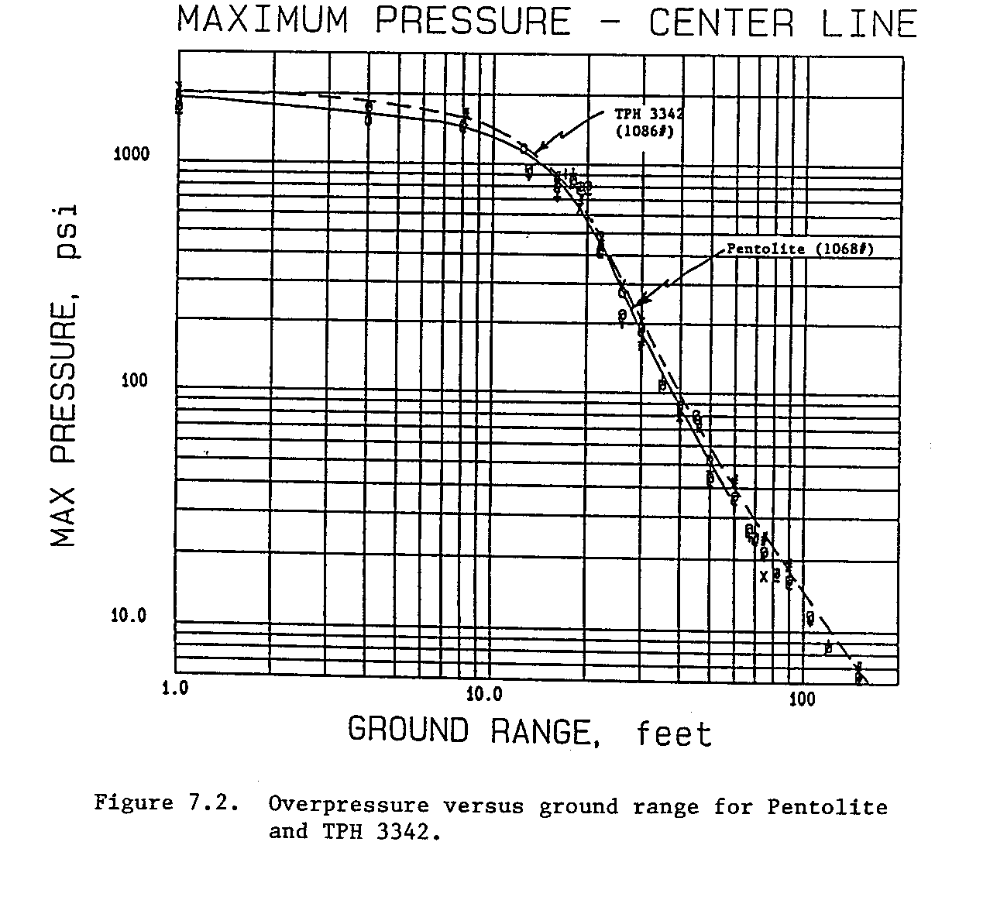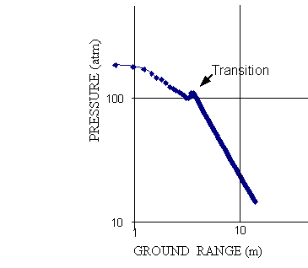
1000
10

P
R
E
S
S
U
R
E
P
S
I
TRANSITION
(a) (b)

Figure 4. Overpressure versus range for: (a) two 1000 lb charges detonated at 25 ft, and (b) a 1 kg charge detonated at 1 m, derived from the AirBlast database of photogrammetric measurements. Both show a similar pressure increase in the transition region.

When a height of burst is selected in AirBlast, the program identifies the measured pressure-distance relationship from two experiments with heights of burst that bracket the selected height. The program then interpolates the pressure at each distance for that selected height. The output of such a result from AirBlast is shown in fig. 4b, and the similarity with the results in fig. 4a may be noted.
AirBlast was used to calculate the pressure distance relationships for a series of heights of burst, with small increments in height. These results were interpolated to provide the distances of the specific overpressures used in the Reichenbach-Kuhl curves. These are plotted as +s in fig. 5 and clearly show knees that were not detected by Reichenbach and Kuhl. A charge mass of 1.25 kg of TNT was used to best match the Reichenbach-Kuhl curves. In general, the points are to the left of the curves in the regular reflection region and to the right in the Mach stem region. This is to be expected because the small-scale experiments were performed over a rigid smooth surface, whereas the AirBlast results are from field experiments in which the shocks were reflected from natural soil surfaces.
As a result of these measurements and observations we conclude that there is a pressure increase at transition from regular to Mach reflection for blast waves from explosions above the ground, and reflections from curved wedges. The ability to detect the increased pressure depends on the frequency response and size of the gauge, or the resolution of a hydrocode calculation. It therefore appears that height-of-burst curves do have knees, but the size and significance for a given sensor, or structure responding to the blast, is yield dependent. The pressure increases were not detected in the small-scale experiments of Reichenbach-Kuhl, but were detected in field experiments with charges of 500 kg and higher. This effect may be of importance to the loading of structures from large nuclear explosions.
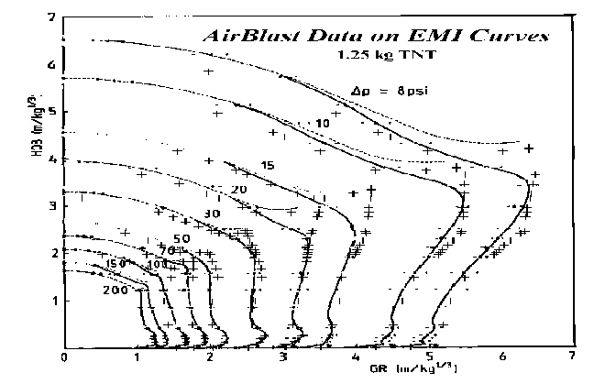
Figure 5. Height-of-burst curves. The lines are Reichenbach and Kuhl results using 0.5 g charges detonated above a rigid smooth surface, and scaled to 1 kg TNT. The points (+) are AirBlast data for 500 kg TNT charges detonated above natural ground surfaces, scaled to 1.25 kg TNT.

AirBlast makes it possible to develop the height-of-burst curves for dynamic pressure, and in this case, the enhancement of pressure in the transition region is much more apparent, as can be seen in figure 6. The considerable increase of dynamic pressure immediately after transition is clearly evidenced by the observed greater displacement of smoke tracers below the triple point, compared to the displacement above. This information will be presented in greater detail in future publications.

Conclusions
As a result of the re-evaluations of experimental field-trial data, and the new pressure measurements on curved wedges, it is concluded that there is a significant increase of hydrostatic and dynamic pressure in the region of transition from regular to Mach reflection for height-of-burst explosions. The ability of a pressure gauge or a structure to sense the pressure increase, depends on the size of the gauge or structure relative to the energy release from the explosion. The effect is undetectable for very small explosion, e.g. 0.5 g; is detectable for explosions greater than 500 kg, and may be of considerable significance in the case of kiloton and megaton explosions.

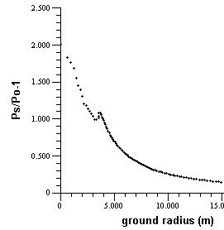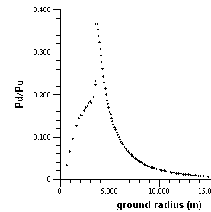
- (b)

Figure 6. (a) Hydrostatic overpressure (atm) and (b) dynamic pressure (atm) plotted versus ground range for a 1 kg charge of TNT detonated at a height of 3 m, derived from AirBlast. The large enhancement in dynamic pressure after transition is clearly seen.

Acknowledgements
The authors gratefully acknowledge the assistance of Gerry Carpenter who provided the gauge for use in the curved wedge experiments, and of Gerry Carpenter and Fred Sauer for their continued interest and valuable discussions about the topic discussed here.

References
[1] Reichenbach, H, and Kuhl, A., 1990, HOB Curves for 0.5 g NP Charges, Ernst Mach Inst, E10/90
[2] van Netten, A. A., Carpenter, J. and Dewey, J. M., 1997, Pressure Changes at Transition from Regular to Mach Reflection, Proc. 15th Int. Symp. Mil. Aspects of Blast and Shock, Defence Res. Est. Suffield, III, 163-174.
[3] von Neumann, J., 1943, Oblique Reflection of Shocks, Explos. Res. Rep. 12, Navy Dept., Bureau of Ordnance, Washington, DC, USA.
[4] von Neumann, J., 1943, Refraction, Intersection and Reflection of Shock Waves, NAVORD Rep. 203-45, Navy Dept., Bureau of Ordnance, Washington, DC, USA.
[5] Brode, H. L., 1970, Height of Burst Effects at High Overpressures, Rand, RM-6301-DASA, DASA 2506
[6] Anderson, J., 1970, 1969 1000 lb Airburst Trials: Operations Report, DRES, Suffield Technical Note, 272.
[7] Reisler, R. E., Dixon, L. A. and Keefer, J. H., 1987, HOB Experiments and Charge Development Studies, Proc. 10th Int. Symp. Mil. Aspects of Blast Simulation, MABS10, I, 457.

